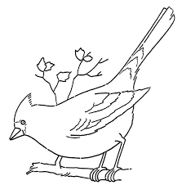
Nom :_______________________

Observation d’oiseaux

Quels types d’oiseaux as-tu vu?
________________________________________________________
________________________________________________________
________________________________________________________

Dessin des oiseaux

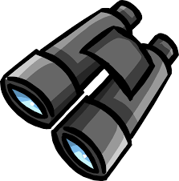

Commentaires/Observations :
________________________________________________________
________________________________________________________

________________________________________________________
________________________________________________________

